LISTA 13

Roberta Cristina de abreu 4°ADS

1)

Listando informações dos arquivos

/etc/hostname, /etc/hosts e /etc/network/interfaces

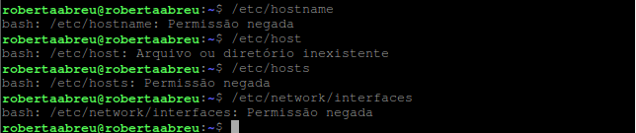

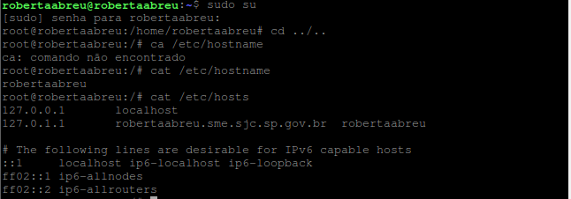

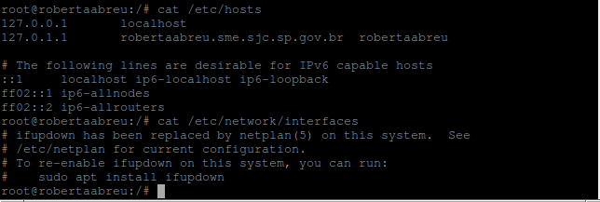

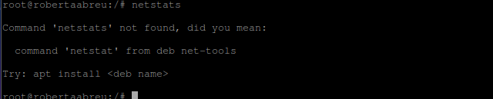

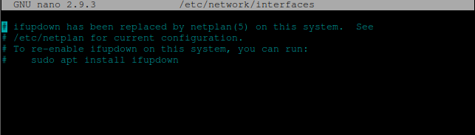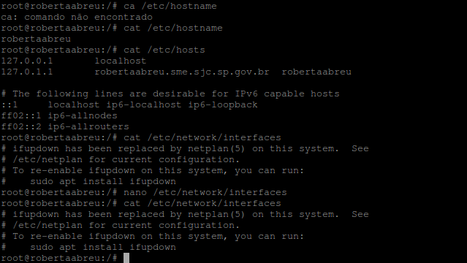

**History 13**

1 history

2 poweroff

3 cd ../..

4 ls

5 cd var

6 ls

7 mkdir d1

8 mkdir d2

9 mkdir d3

10 ls

11 cd d1

12 d1a.txt

13 >d1a.txt

14 >d1b.txt

15 >d1c.txt

16 cd ..

17 cd d2

18 >d2a.txt

19 >d2b.txt

20 >d2c.txt

21 cd ..

22 cd d3

23 >d3a.txt

24 >d3b.txt

25 >d3c.txt

26 ls

27 cd d2

28 cd ..

29 cd d2

30 ls

31 cd ..

32 cd d1

33 ls

34 cd ..

35 backup.sh

36 nano backup.sh

37 mkdir backp

38 nano backup.sh

39 sudo service ssh start

40 ifconfig

41 nano backup.sh

42 crontab -e

43 ls

44 cd ..

45 backup.sh

46 >backup.sh

47 nano backup.sh

48 crontab -e

49 ifconfig

50 history

51 history > history9.txt

52 cat /etc/passwd

53 su user1

54 exit

55 frigobar51

56 su user1

57 exit

58 history

59 exit

60 frigobar51

61 groupadd developers

62 groupadd restores

63 addgroup developers eduardo

64 Addgroup developers eduardo

65 Addgroup developers mariana

66 Addgroup developers abner

67 Addgroup developers davi

68 gpasswd -A debito restores

69 gpasswd -A mariana restores

70 gpasswd -A user1 restores

71 adduser user2

72 gpasswd -A user2 developers

73 su

74 exit

75 cd ../..

76 ca /etc/hostname

77 cat /etc/hostname

78 cat /etc/hosts

79 cat /etc/network/interfaces

80 nano /etc/network/interfaces

81 cat /etc/network/interfaces

82 netstats

83 history < history13

84 history < history13.txt

85 history > history13.txt